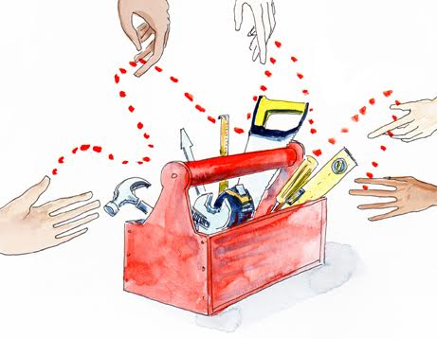

**Remote partnering approaches to simple and complex tasks**

**What makes remote interventions come alive?**

Like it or not, we maintain several relationships, of varying intensities, remotely. We are used to it and it can often feel quite productive and connected. When we meet a colleague only meet once a year, for example, we find we can co-create projects, tools and work processes remotely and it works quite well.

This tool is designed to help those working remotely to build on that sense of connectedness by the **way** we approach our tasks and interventions. Here we have categorised tasks and activities into ‘simple’ and ‘complex’[1].

Simple tasks are those where you can predict the outcomes based on your experience and knowledge. Even if you do not have experience of it, someone else in your team or among your partners may have it. These will be the kinds of tasks for which you can develop guides and checklists, and find good technological solutions.

Complex tasks are those that deal with many variables, and therefore you cannot exactly predict outcomes. There are no straightforward solutions. You will have to experiment and see what works and how far it works and be prepared to take some risks. These are also the tasks where you can hope for breakthroughs, which may change rules of the game.

There is no rule on what is simple and what is complex. It depends upon your partnership and its context. For example, a reporting format can be a simple task in one context, and a complex one in another. So, you will need to generate your own lists, using the examples mentioned to trigger your thinking about your own partnership.

|  |
| --- |
| **SOME EXAMPLES OF SIMPLE TASKS / ACTIVITIES**   1. Sharing updates   *How will updates be shared in a way that maximises chances that they are read by all partners? Do you need protocols on who reads which kind of updates in each partner organisation?* |
| 1. Maintaining regular contact   *What kind of communication protocols do you need? Emails? WhatApp? Phone? What should be the key considerations in preparing the protocols? Ensure openness? Avert communication overload?* |
| 1. Creating a reporting format   *What should be the defining principles for creating a reporting format? Should the format fit in with the data that partners are generating? Are donor requirements different? Where do you need to negotiate? With donors? With implementing partners?* |
| 1. Discussing monthly reports   *Who should be involved in discussing monthly reports? Who should lead? What is the purpose of discussing them? How many people will be involved? Which is the best technology to use in the circumstances?* |
| 1. Discussing new activities   *What is the purpose of introducing the new activity? Who initiated the idea? Does it require major changes? Should it first be discussed one-to-one?* |
| 1. Sharing feedback   *Is the feedback likely to annoy or hurt anyone? What can you do to ensure that the person has scheduled enough time for it? Should it be by mail, or audio-visual, or just audio? What are you most comfortable with? How can you know what the person who will receive feedback is most comfortable with?* |
| **SOME EXAMPLES OF COMPLEX TASKS / ACTIVITIES**   1. Ensuring partners listen to each other and articulate their own views   *It is easier to switch off mentally, or work alongside and pay partial attention. How can you check without policing? Remember, even in face-to-face interactions, partners are not all ‘present’ always. Can you share snippets and anecdotes, rather than data? What kind of mindset change will it require?* |
| 1. Facilitating open discussions on challenges and ‘failures’   *What questions can you pose? How can you use stories for insights? Are you looking for details? Or for insights? Can you invite challenges to/critique of each other’s behaviour / approaches during the conversation?* |
| 1. Eliciting feedback and receiving feedback   *How can you ensure that partners feel able to voice their genuine concerns, questions and challenges? How would you gauge tone of voice? How do you interpret silence when you ask a question? Are they thinking, or avoiding, or uncomfortable to speak? Are they saying ‘yes’ too fast? Are they elusive?* |
| 1. Challenging mind sets and practices   *How comfortable are you with challenging? How can you do it respectfully? What can be the means of damage control, if required?* |
| 1. Negotiating serious differences of opinions   *Can a virtual space become a real space? Should the differences be resolved or embraced?* |
| 1. Challenging violations of partnering principles   *Have the partners agreed on the principles for the partnership? Is it worth discussing? Is it worth making explicit your own partnering framework? When should introduce the partnering idea and invite discussions on them?* |

1. The categorisation has been inspired by the Cynefin framework, developed by Dave Snowden. Check out the video on Youtube <https://www.youtube.com/watch?v=N7oz366X0-8>