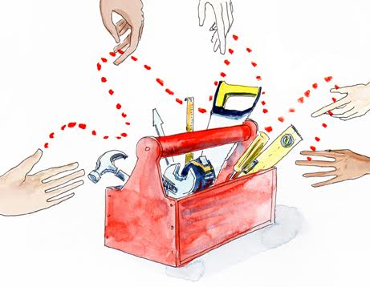

**The Leading Change Checklist**

To **get beyond** where we are now will take persistence, imagination and leadership. But what kind of leadership is appropriate for a partnership where there is commitment to equity, co-creation and collaboration? It seems that partnering not only requires us to explore a new model of working but it is also requires us to explore and to model new forms of leadership.

What do the experiences of those currently involved in partnerships reveal about what leadership qualities will be needed to create the future we want?

|  |  |  |
| --- | --- | --- |
| **Experiences, insights and hopes reported by practitioners involved in the DEPP** (recorded between 2016-17)**:** | **New leadership qualities required** | **To what degree is this present?** |
| *“The conflicts that arose between the partners could have been avoided if we had focused on building the relationship and paid more attention to the challenges of working remotely”* | Being observant and attentive |  |
| *“Going beyond ‘the agenda’ is a big challenge in long distance communication – but it is essential and if we can get it right it will make all the difference”* | Going beyond the obvious |  |
| *“In remote partnering you have far less control – you have to shift control to the other person… and you have to assume and trust that the other person has the capacity”* | Having faith in others |  |
| *‘Greater clarity of roles and responsibilities, combined with a shared vision and open communication channels will make remote partnering ever more effective.’* | Sharing responsibilities |  |
| *“All our partnerships have to be locally driven. INGOs should be only catalysts – this is the first step in really shifting power and not just talking about it”* | Willingness  to let go |  |
| *“What would it take to have an honest design that recognizes corruption as a significant issue and a major influencing factor? This requires serious critique of our current practices and significant adjustment at all levels”* | Having the courage  to be honest |  |
| *“My hope is that by being constructively disruptive we can bring about serious change at a local level rather than just imposing a centrally controlled agenda”* | Challenging when necessary |  |
| *“Being really open to a different future may bring up new / unexplored / unexpected opportunities just because we have done things differently”* | Being open to discovering what you don't yet know |  |