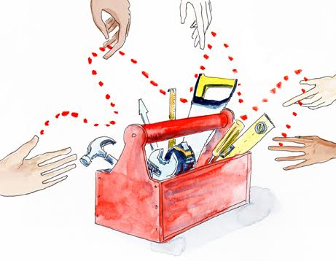

**Practitioners as Learners and Teachers**

If every partnership is a journey, if we are to be genuinely open to what is needed for that journey to arrive at a good destination and if there are many options on both the method and direction of travel, we need to be ready to able to build on experience. Partnering requires us all to be both learners and teachers. We all have unique knowledge and experience to share and we all need to recognise that we don't know what we don't know!

In this tool, we do not distinguish between learning and teaching since the same activity or role can contribute to both. What we are concerned with is the development of learning and teaching mind-sets that will benefit both the individuals involved and the partnership as an entity.

There are a number of possible roles that enable us to learn and teach – and many can be deployed within a partnership either formally (the role is a contractual one) or informally (the role is adopted spontaneously and on a voluntary basis).

**Role characteristics – selecting the appropriate role for what is needed**

|  |  |  |
| --- | --- | --- |
| **Role:** | **Characteristics:** | **Appropriate when…** |
| **Coach** | Specific practical skills that can be imparted to others who improve their partnering with the benefit of supervised practice | …it is clear what specific skills are lacking that are holding back the progress of individual partners or the partnership |
| **Critical friend** | Willing to suspend their own opinions and offer to give considered feedback in a non-judgmental way | …there is a culture of feedback in the partnership – works best when 2 partners are critical friends to each other |
| **Facilitative leader** | Ability to see what is needed and to take a lead in ensuring it happens on behalf of the group not from their own egos | …it is clear that traditional forms of leadership / assumed authority are not what the partnership needs and it is necessary to change working practices |
| **Observer** | Willingness to stay silent and just take note of what is happening in order to assist partners to understand patterns and impacts of their behaviour | …groups (and those leading / facilitating them) are getting stuck and need assistance in understanding where the blocks are and what needs to change |
| **Mentor** | Someone who brings mature experience and a level of wisdom to a partner / partnership and is willing to support the learning and sense-making process | …the partners are new to partnering and / or the partnership is in its early stages and those involved do not have relevant partnering experiences to build on |
| **Partnership broker** | An individual who takes on a high level coordination / path-finding role on behalf of the partnership and assists partners in the collaboration process | …partners need assistance: in addressing challenges; holding space for new thinking; in navigating diversity, differences of opinion and divergence |
| **Role model** | An ability build new skills and approaches by their example (how they partner) rather than by more formal instruction | …more formal training is not available or acceptable (for example to those they think already know how best to partner) |