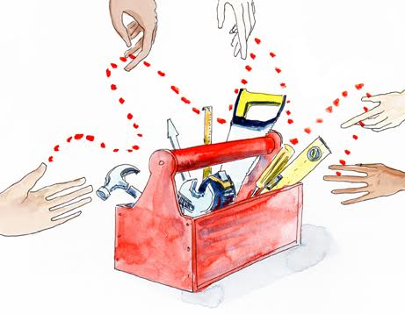

**Partnering Self-assessment Questionnaire**

If you want to **get better** at partnering it’s a good plan to start by assessing what you currently do, how you feel about the partnership and the partnering process and where there might be room for you to do things differently. This is an opportunity to step back, take stock and reflect.

**Your current role in the partnership:**

What term(s) best describe your current partnering role?

(Circle as many as you think are appropriate)

Administrator Advocate Ambassador Animator Bridge-builder Broker Coach Communicator Coordinator Disrupter Educator Evaluator Facilitator Guardian Innovator Interpreter Manager Mediator Monitor Negotiator Organiser Pioneer Record-keeper Researcher Resource-mobiliser…

Are there other roles you play? If so, what are they?

How well do you feel you fulfil them? What could you do differently? How could others assist?

**Your contribution to the partnership:**

What is your unique contribution to your partnership?

(Summarise in 50 words!)

What more (or what different things) could you contribute?

**General partnering skills and attributes:**

|  |  |  |
| --- | --- | --- |
| **Skills:** | **How do you rate yourself?** | **What would it take to do better?** |
| Active listening |  |  |
| Precise speaking |  |  |
| Giving feedback |  |  |
| Good time-keeping |  |  |

|  |  |  |
| --- | --- | --- |
| **Attributes:** |  |  |
| Empathy |  |  |
| Sensitivity |  |  |
| Honesty |  |  |
| Commitment |  |  |

**Partnering long-distance:**

Attitude to / feelings about long-distance partnering

(Put an ‘X’ somewhere along each spectrum)

|  |  |  |
| --- | --- | --- |
| Absolutely hate it | **WORKING ALONE**  ALONE | Absolutely  love it |
| Very unconfident | **WORKING WITH ON-LINE COMMUNICATION PLATFORMS**  ALONE | Very  confident |
| Extremely challenging | **EXPERIENCE OF REMOTE PARTNERING TO DATE**  ALONE | Extremely  exciting |

What would help you to partner long-distance more effectively?

**Are there any other reflections on your partnering challenges and opportunities?**

**Check list of possible actions / resolutions resulting from completing this questionnaire:**

**Ask** other partners to consider your perspective / context more carefully

**Invite** constructive critique from partners / colleagues

**Request** help where you feel you need it

**Offer** help where you think you can

**Learn** more about partnering from reports, papers, case studies (from the internet) and / or project visits

**Seek** advice / guidance from someone with more partnering experience

**Take** a specialist training in partnering or related skills (face-to-face or on-line)

**Keep** a partnering journal

**Or**…

